**Assignment Report**

**Course:** Ai Assisted Coding

* **Student Name:** T.MANIKANTA
* **Roll Number / ID:** 2403A51290
* **Batch :** 24BTCAICSB12

**Date of Submission:** 21st August 2025

**Table of Contents**

1. **Task 1** – Bank Account Class
2. **Task 2** – For Loop to Sum Even Numbers
3. **Task 3** – Age Group Classification
4. **Task 4** – While Loop to Reverse Digits
5. **Task 5** – Employee → Manager Inheritance
6. **Conclusion**

**Task 1: Auto-Complete a Python Class for Bank Account**

**Task Description:**  
Create a BankAccount class with attributes account_holder and balance. Add methods to deposit, withdraw, and display the balance.

**🔹 Python Code  
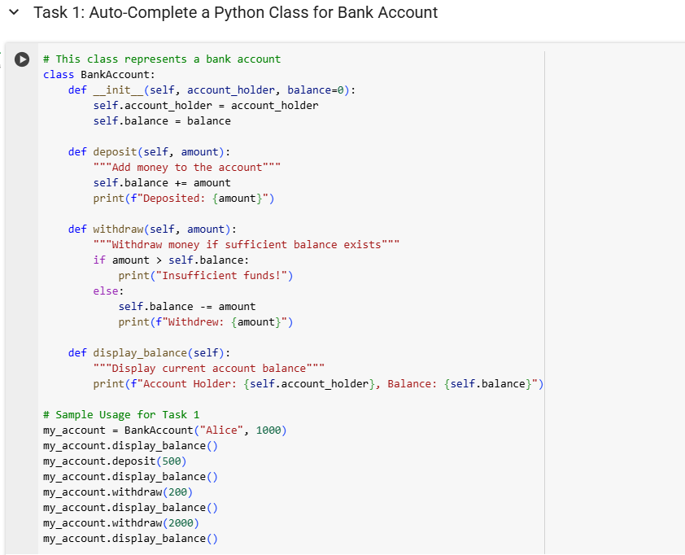  
  
🔹Output**

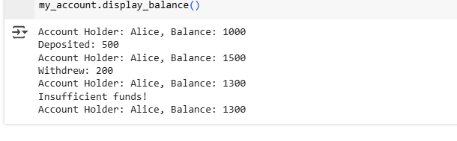

**Task 2: Auto-Complete a For Loop to Sum Even Numbers in a List**

**Task Description:**  
Iterate a list, check if the number is even, and calculate total of even numbers.

**🔹 Python Code**

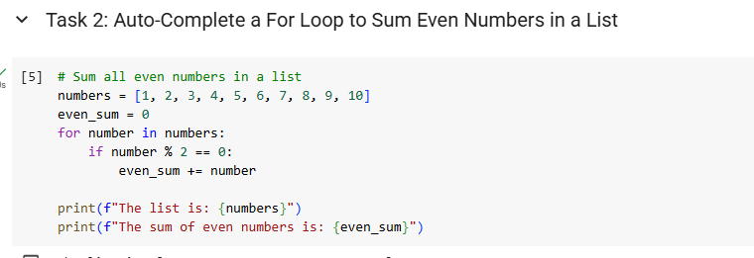**🔹 Explanation**

* Loops over the list.
* Checks num % 2 == 0.
* Adds even numbers to the accumulator.

**🔹 Output**



**Task 3: Auto-Complete Conditional Logic to Check Age Group**

**Task Description:**  
Design a function to classify age into categories.

**🔹 Python Code**

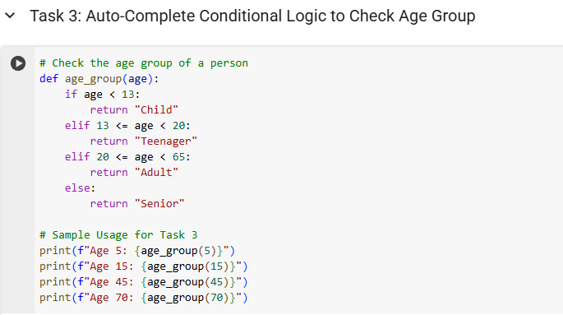**🔹 Explanation**

* if-elif-else structure handles classification.
* Ranges: <13, <20, <60, else Senior.

**🔹 Output**

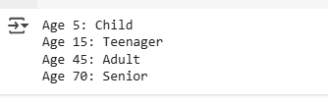

**Task 4: Auto-Complete a While Loop to Reverse Digits of a Number**

**Task Description:**  
Reverse an integer using while loop.

**🔹 Python Code**

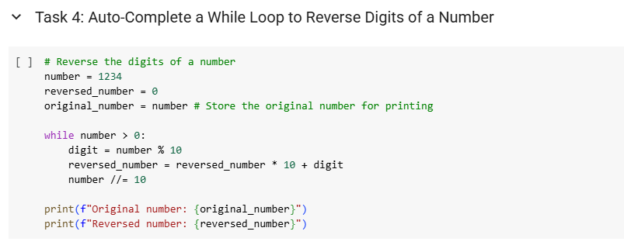**🔹 Explanation**

* % 10 extracts last digit.
* Builds reversed number iteratively.
* Number shrinks using // 10.

**🔹 Output**



**Task 5: Auto-Complete Class with Inheritance (Employee → Manager)**

**Task Description:**  
Implement class inheritance where Manager extends Employee.

**🔹 Python Code**

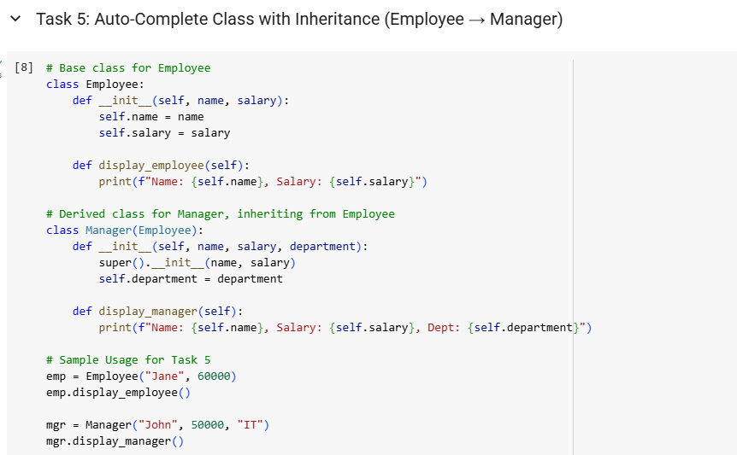**🔹 Explanation**

* Manager reuses Employee constructor using super().
* Adds department.
* Overrides display() for extended output.

**🔹Output**



